VPC TASK -2
1)Create one VPC, with 1 public subnet and 1 private subnet.
Opened VPC service and clicked Create VPC.
• Selected VPC and more, entered name and CIDR block.
• Created 1 public subnet and 1 private subnet, then
clicked Create VPC.
• VPC my-vpc-2-vpc was created successfully and is in
available state

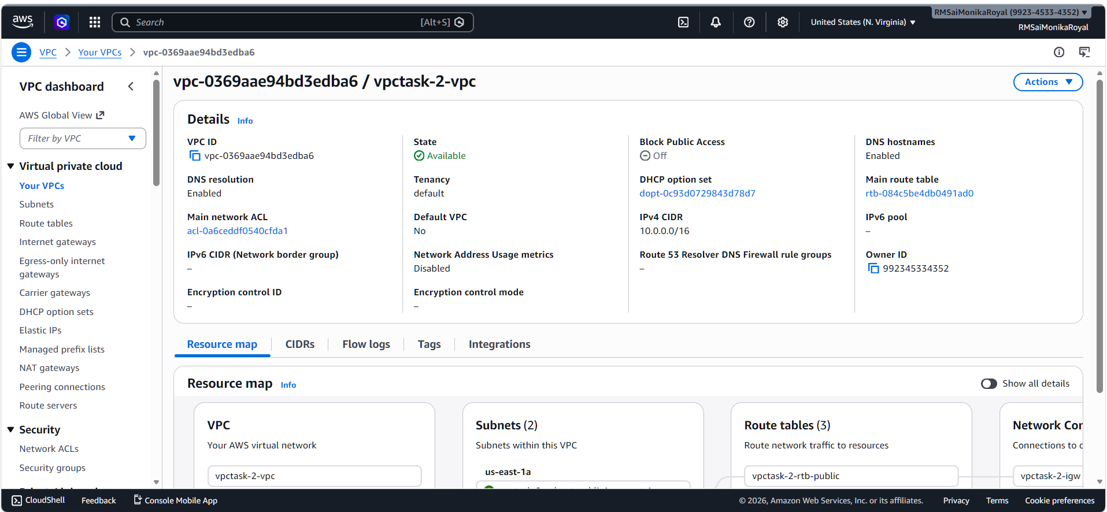

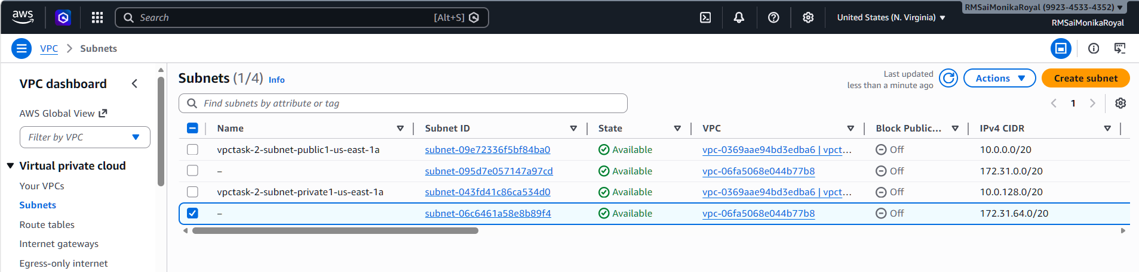

2) Enable VPC peering for cross-region.
Created a vpc with 2 subnets
• Creating a peering connection in same account but
different regions.
• After sending request accepted the peering request
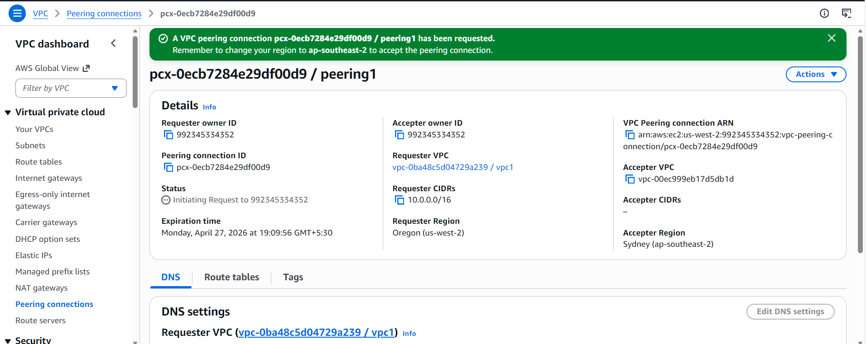
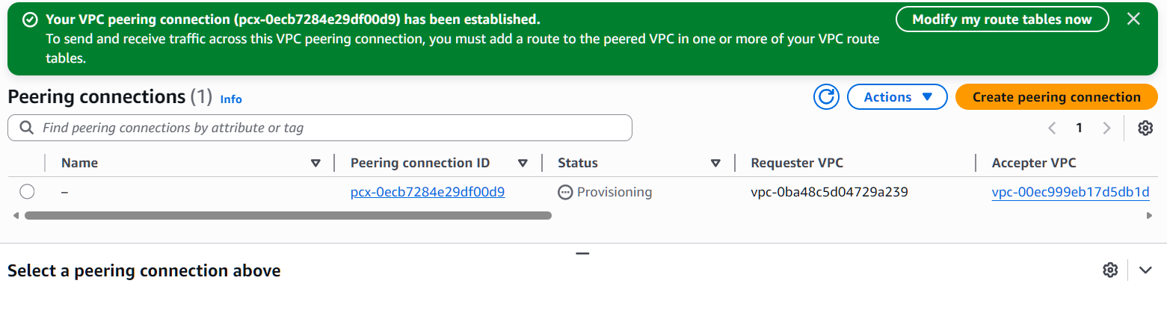
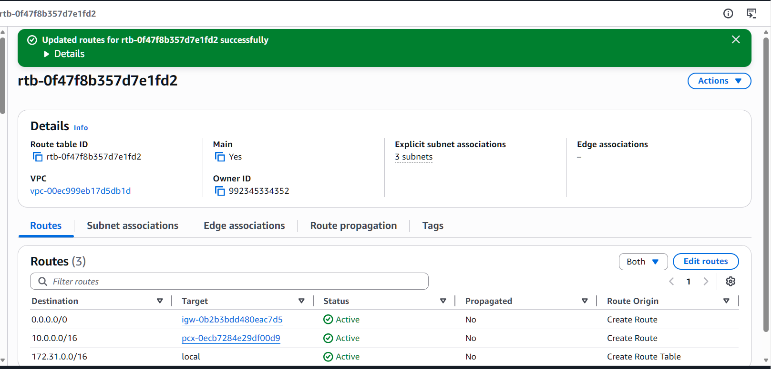
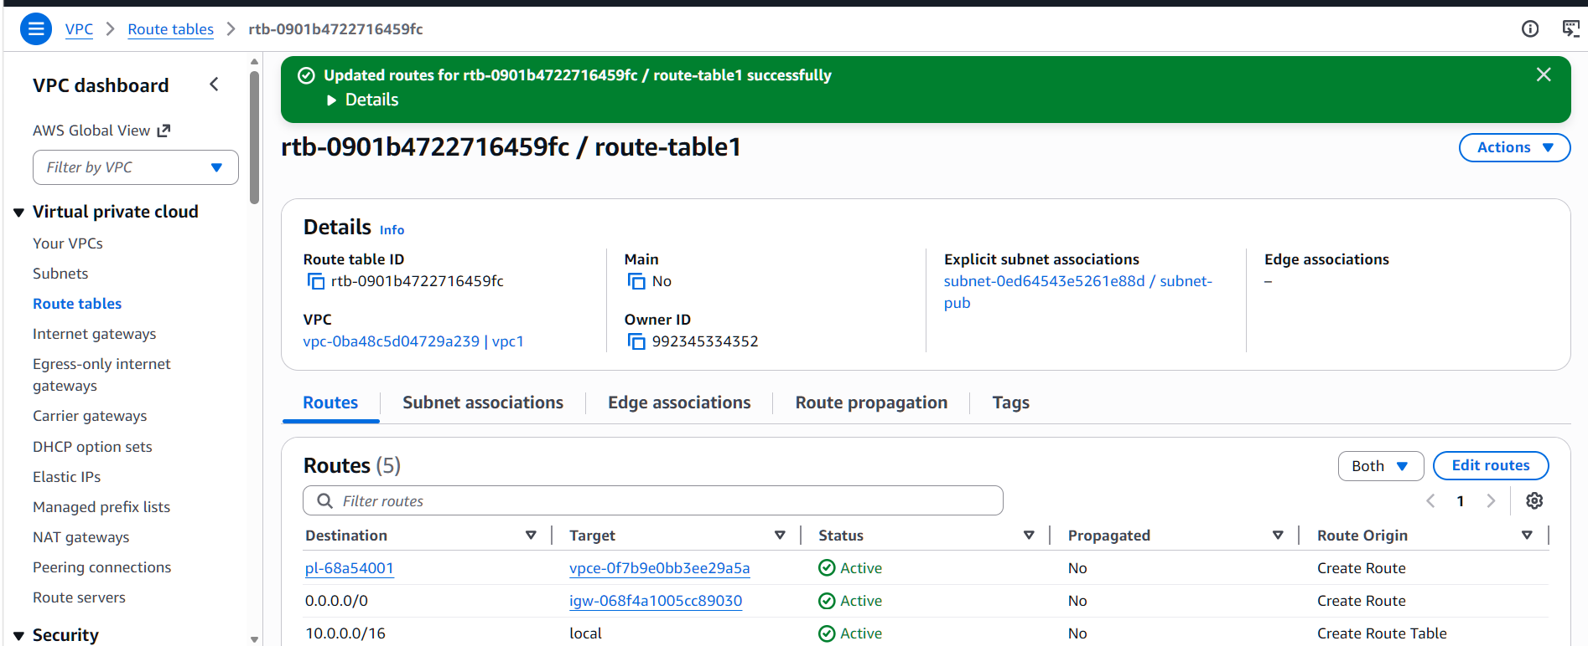

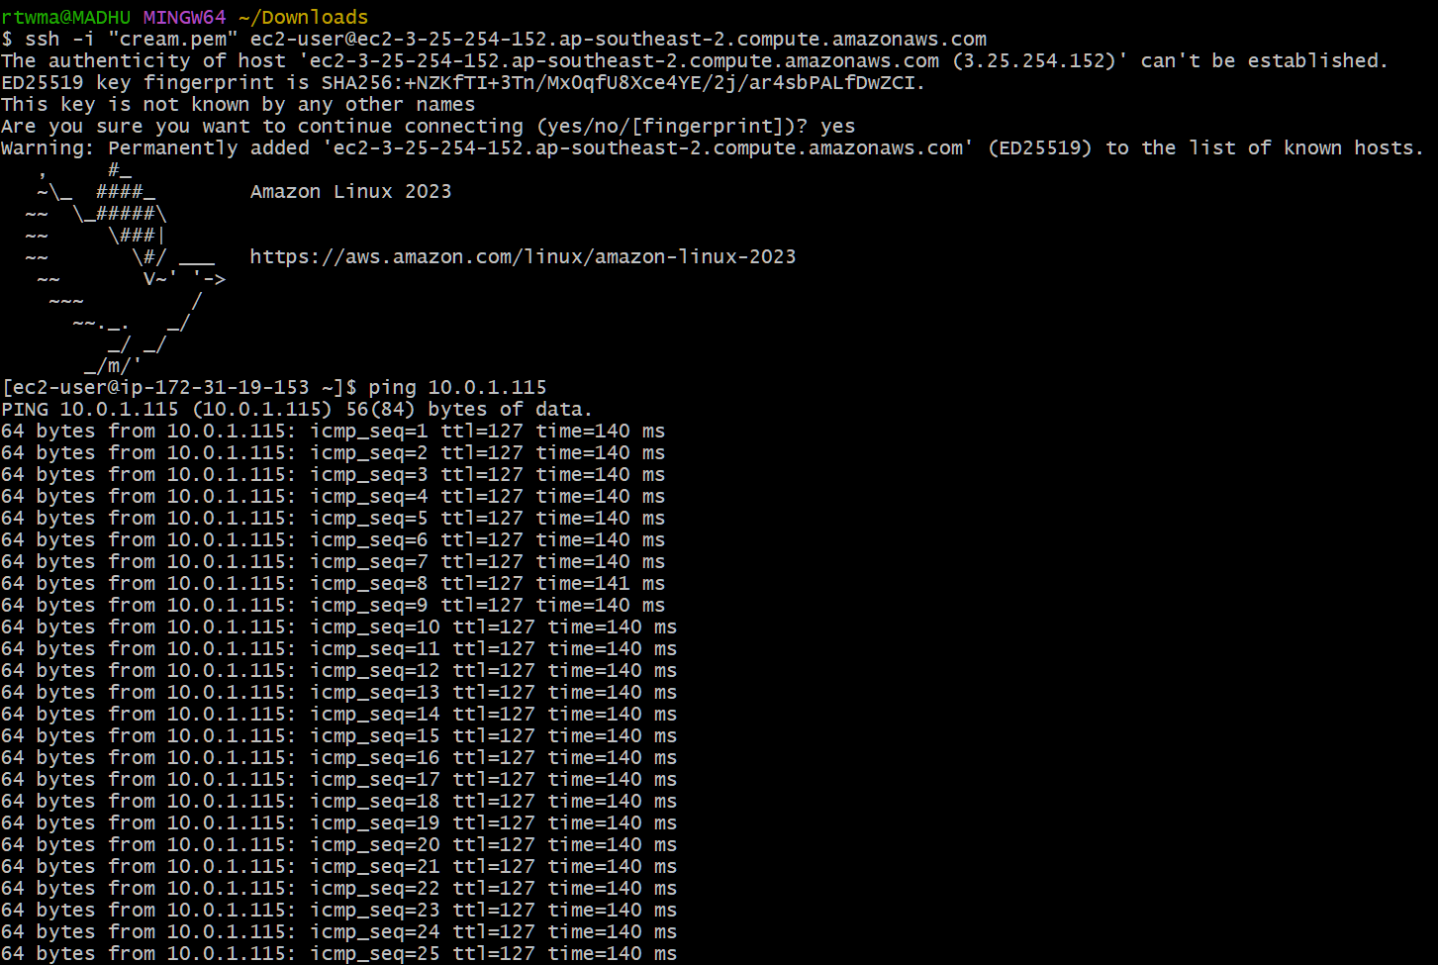

3) Enable VPC peering for cross-account (you can collaborate with your friend to do this task).
Creating a peering request with another aws account
• Sent request and request is accepted
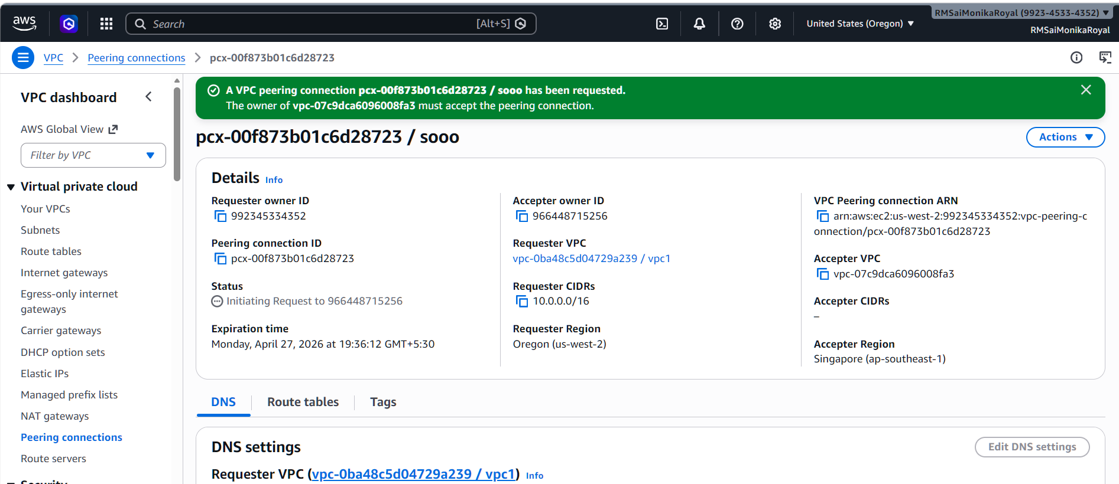
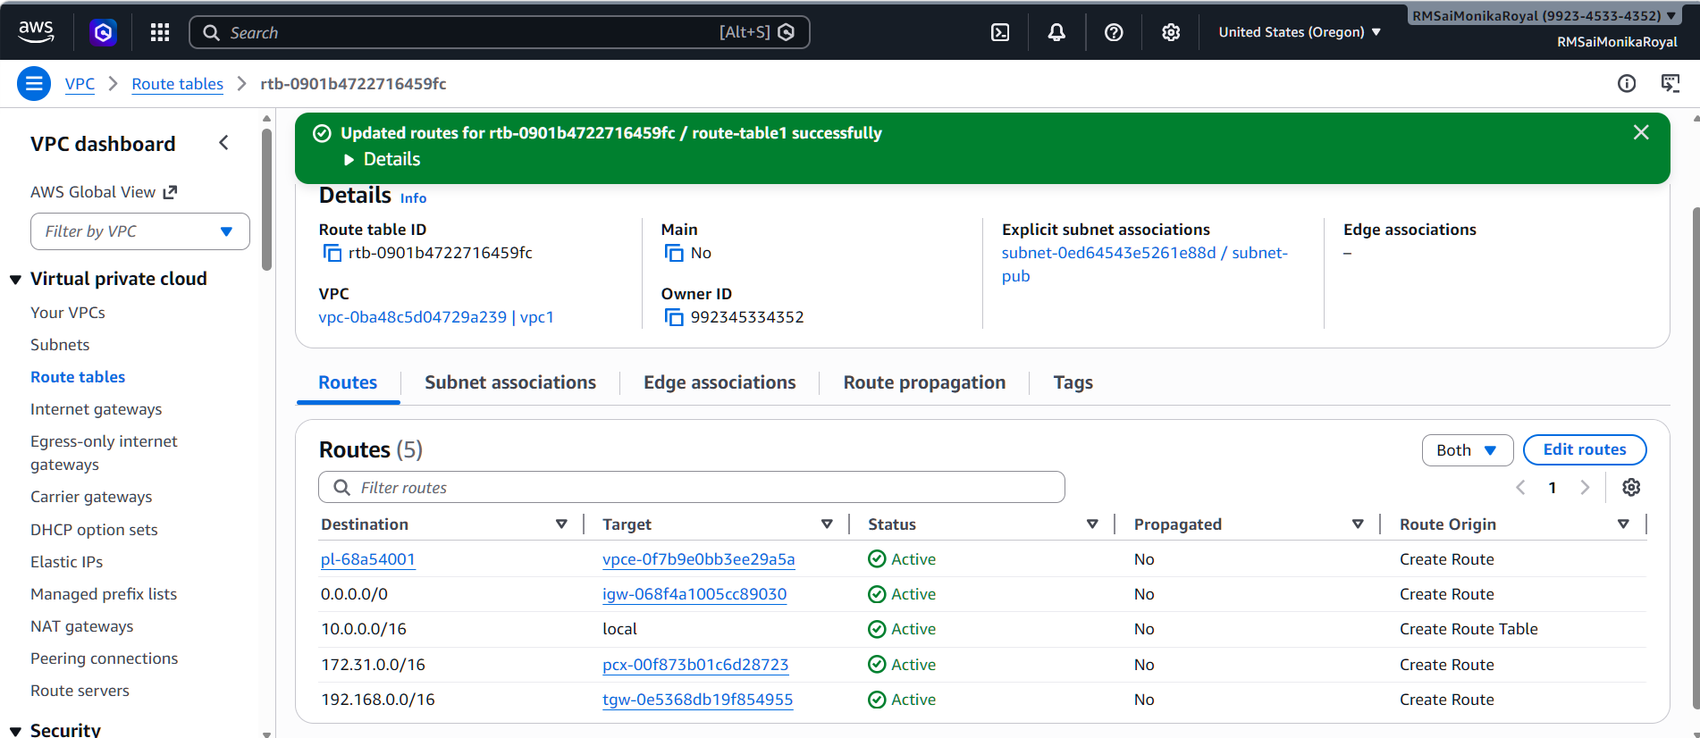
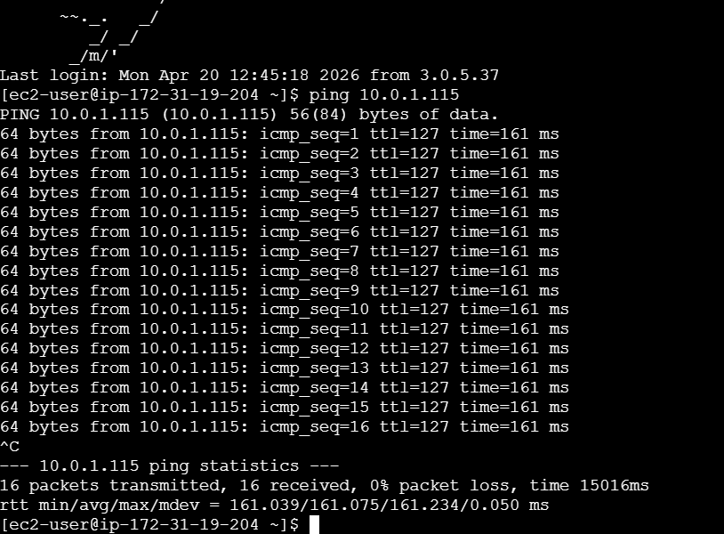
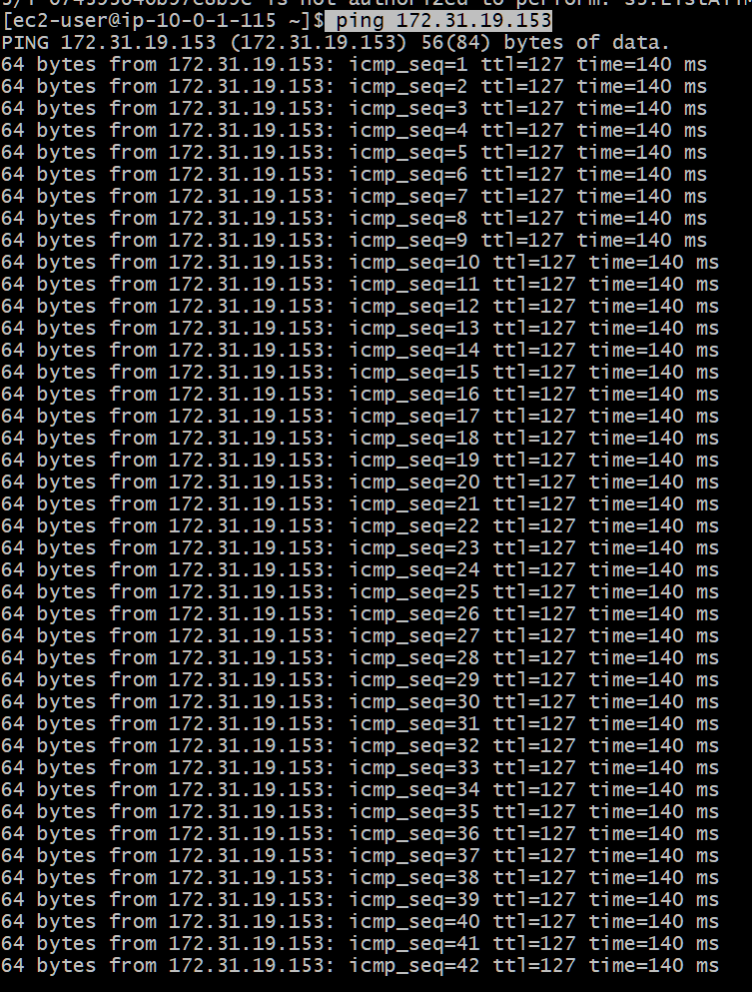

4) Set up a VPC Transit Gateway.
• Created two vpcs
• Created one Public subnet in vpc1
• Created one Private subnet in vpc2
• And created 2 route tables one for vpc1 and second
one for vpc2
• Created one internet gate way and attached to vpc
• Created two transit gateways
• Added transit gateways to route tables
• Created two ec2 instances one public and another
one is privat
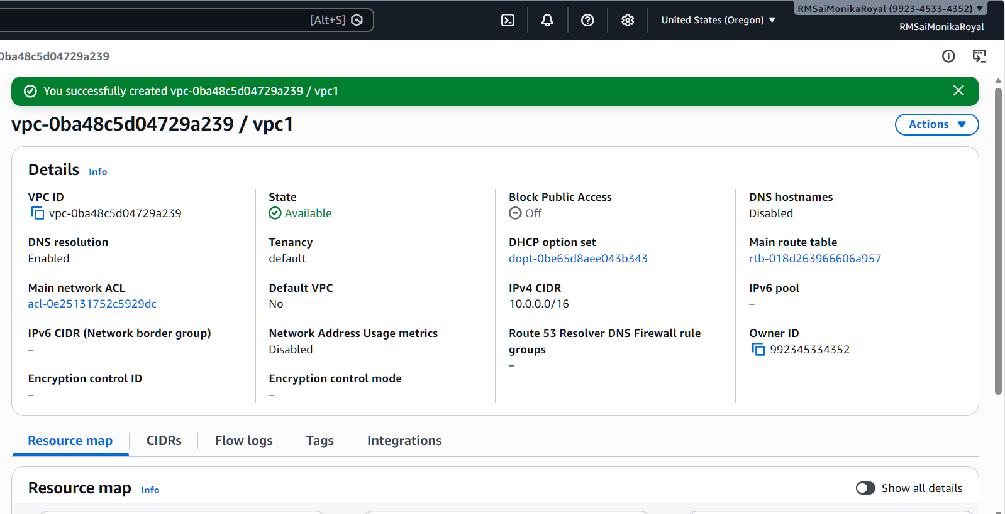
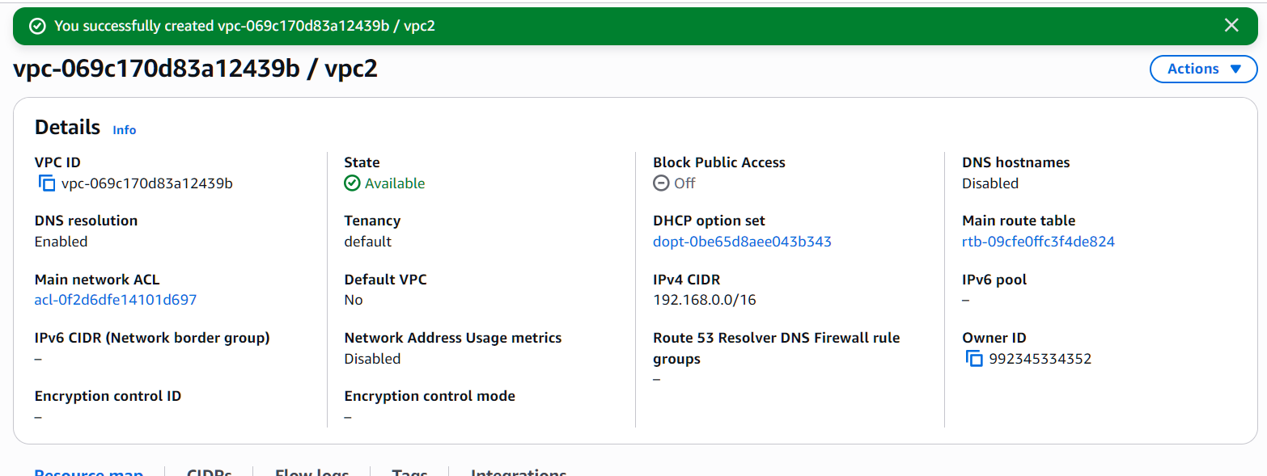
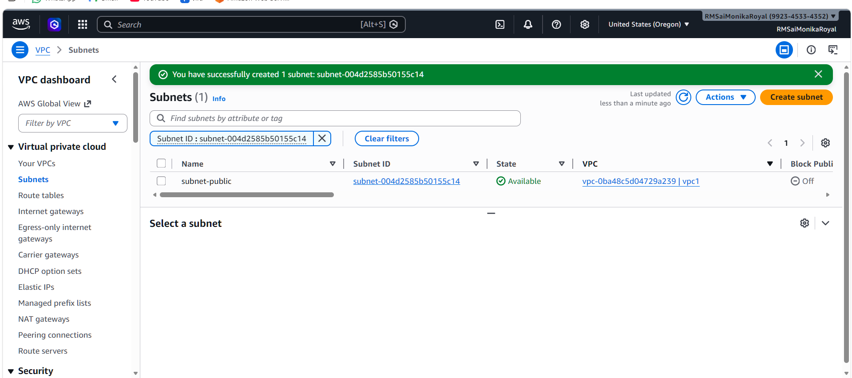
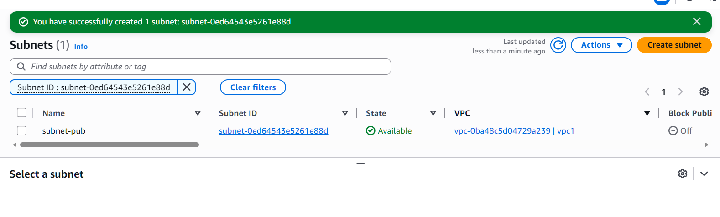
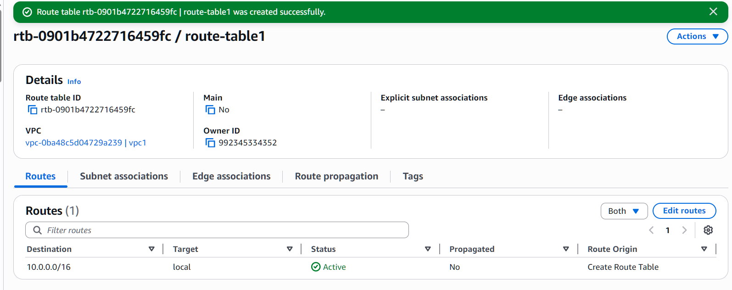
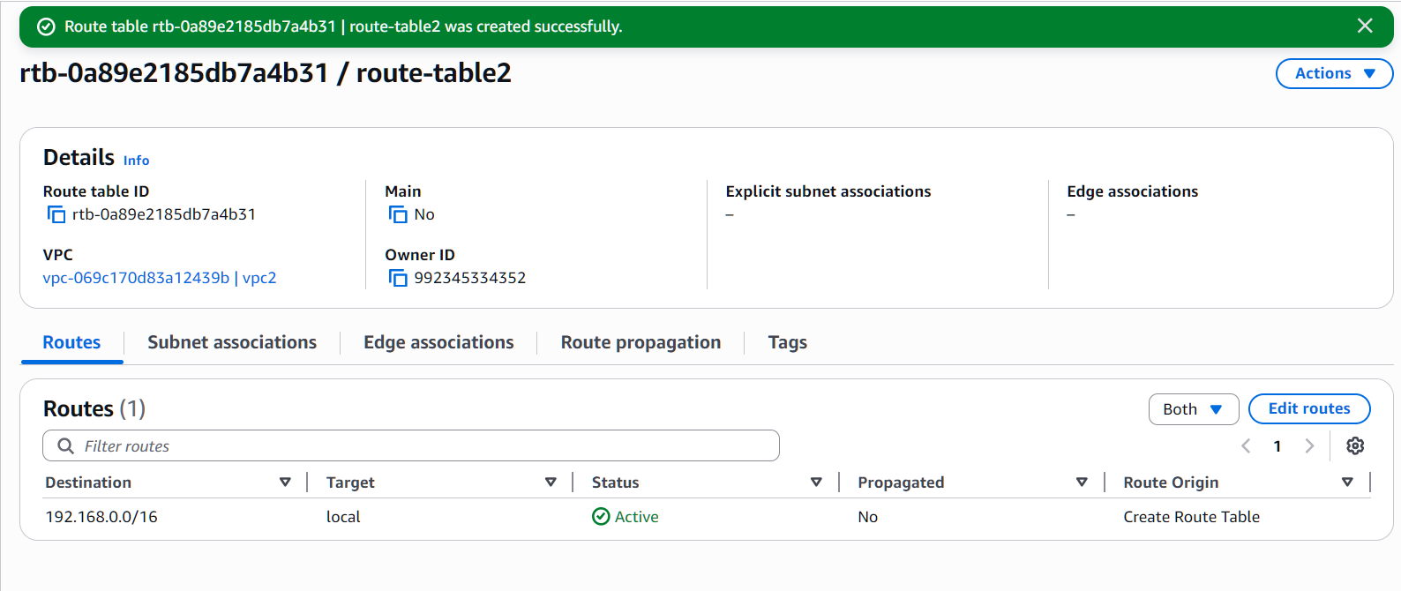
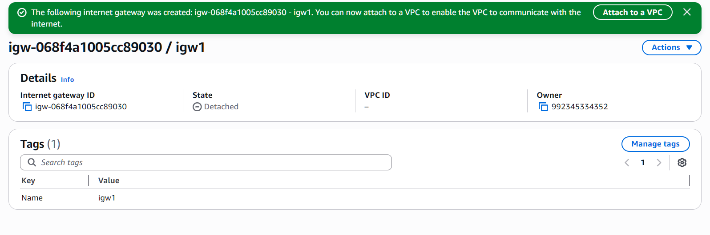
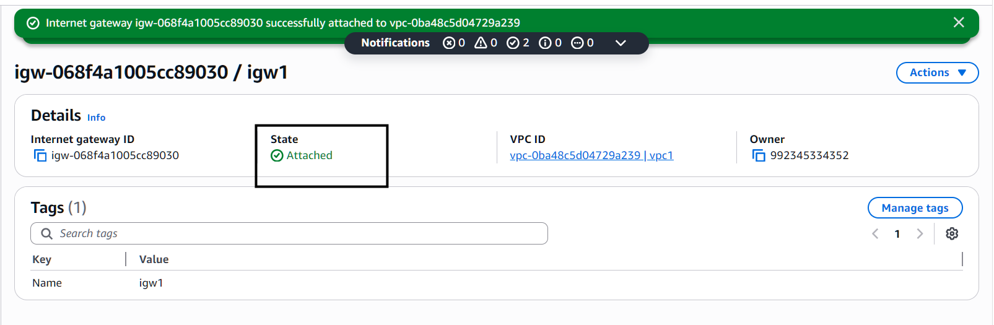
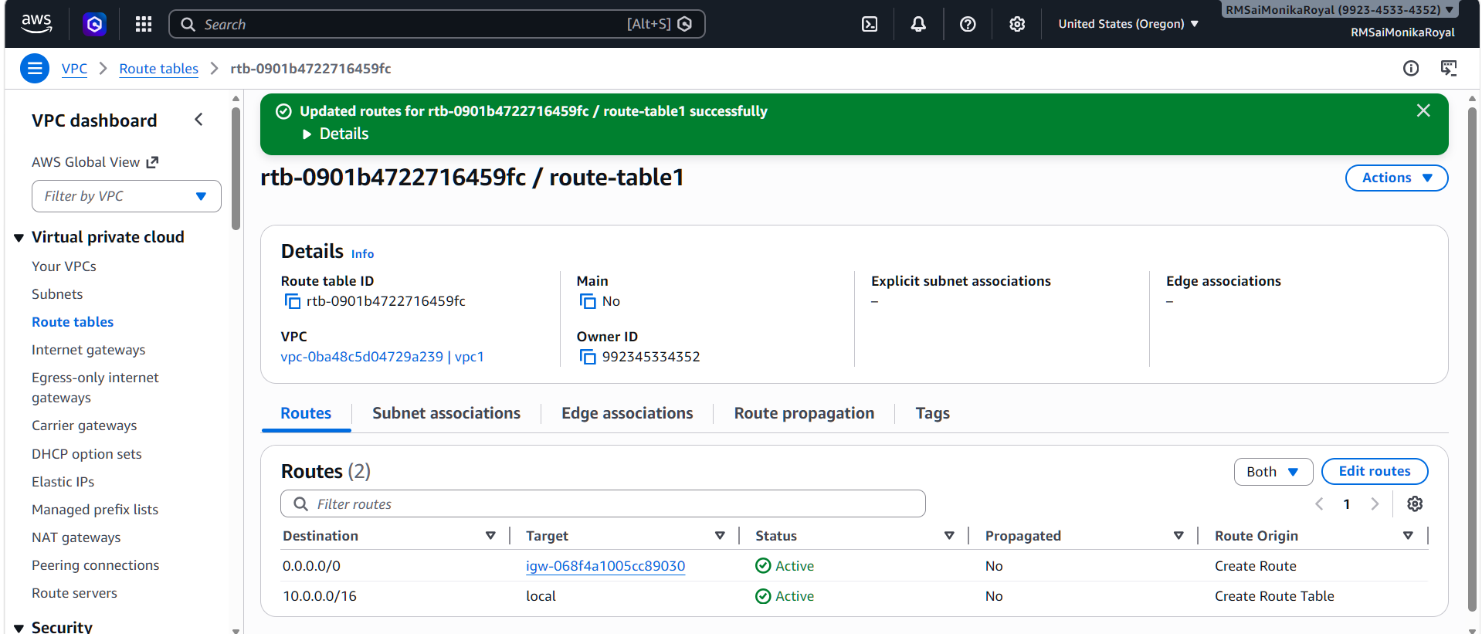
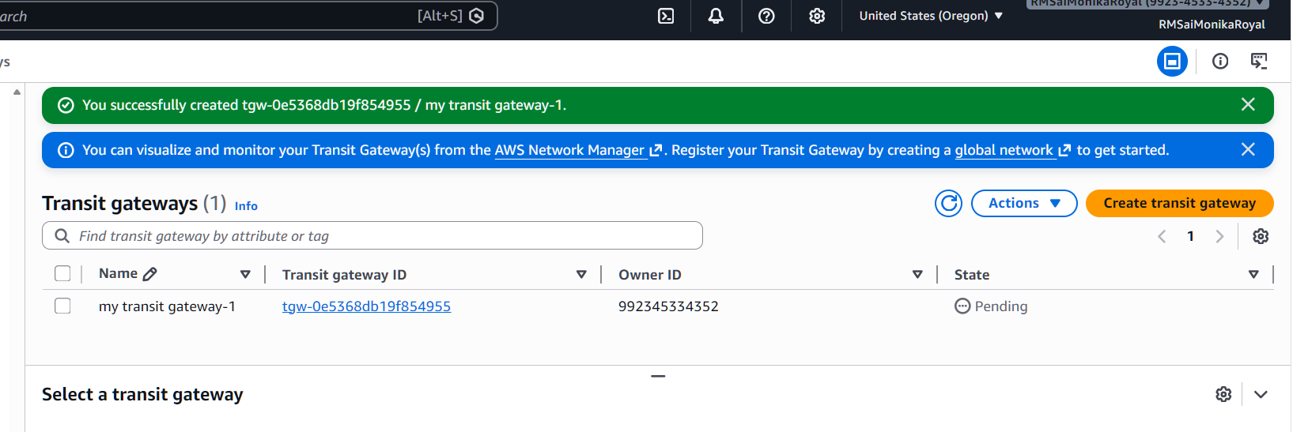
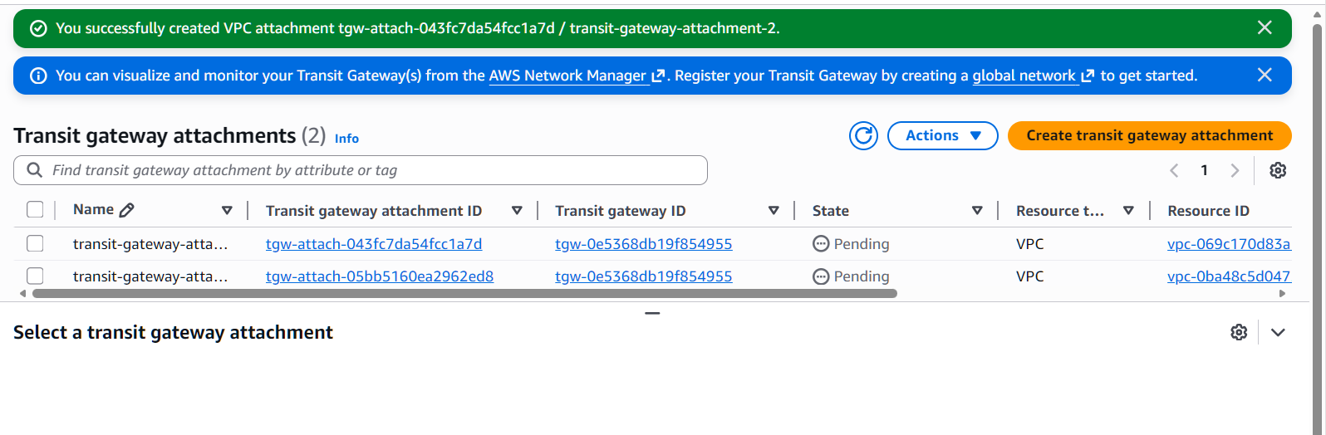
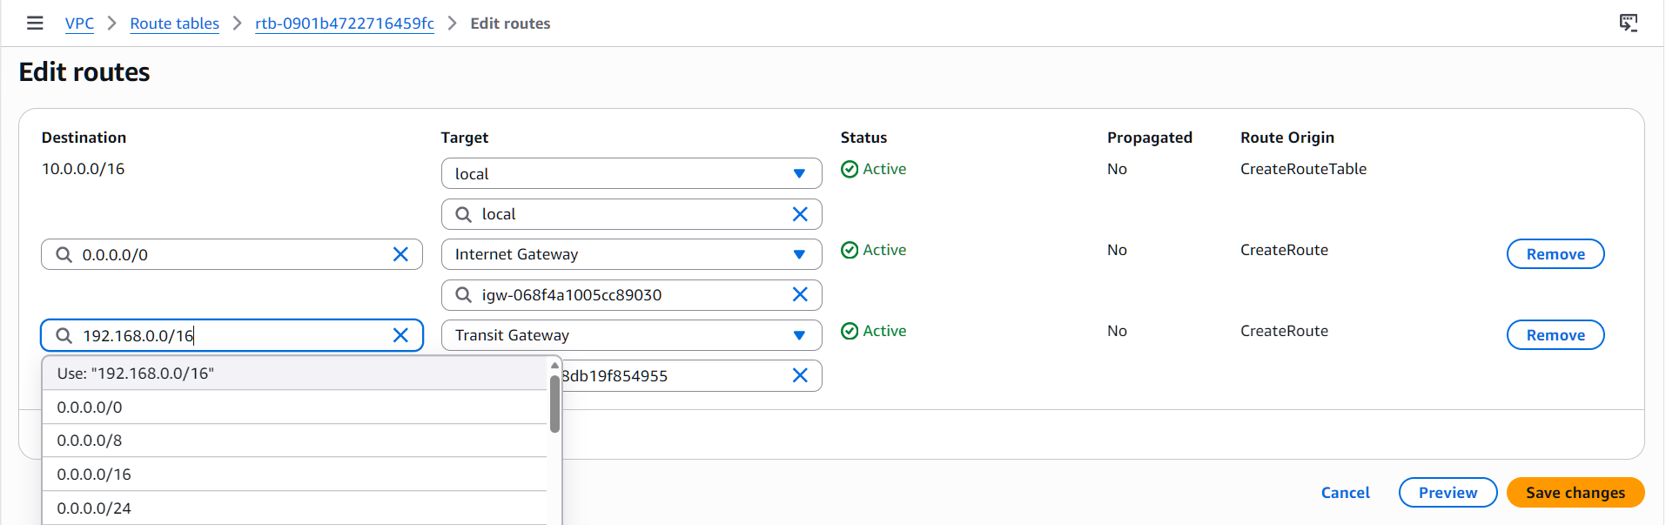
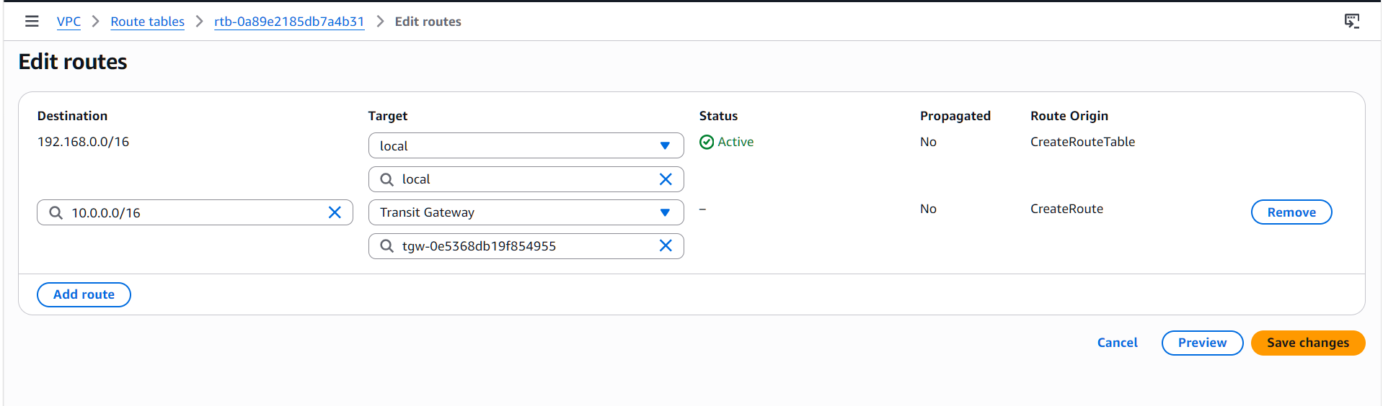
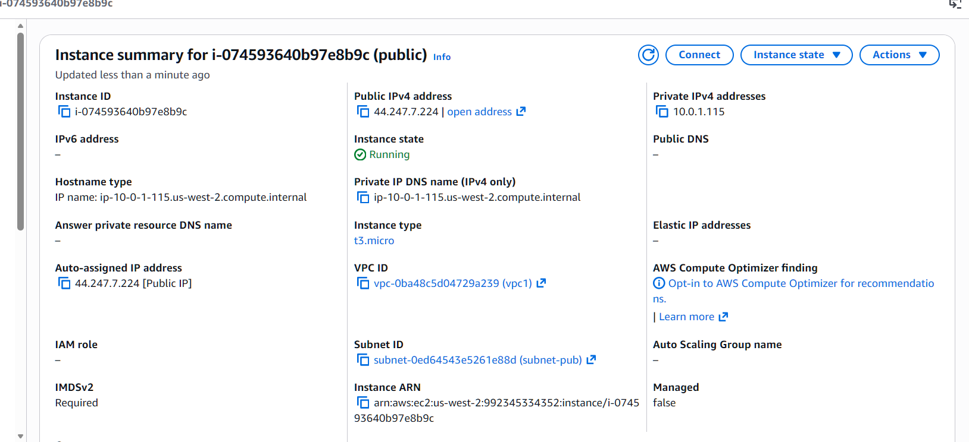
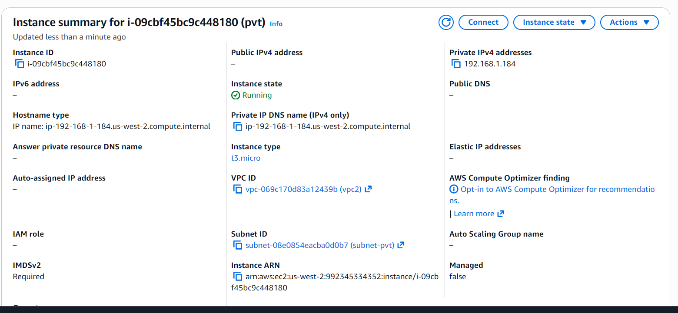
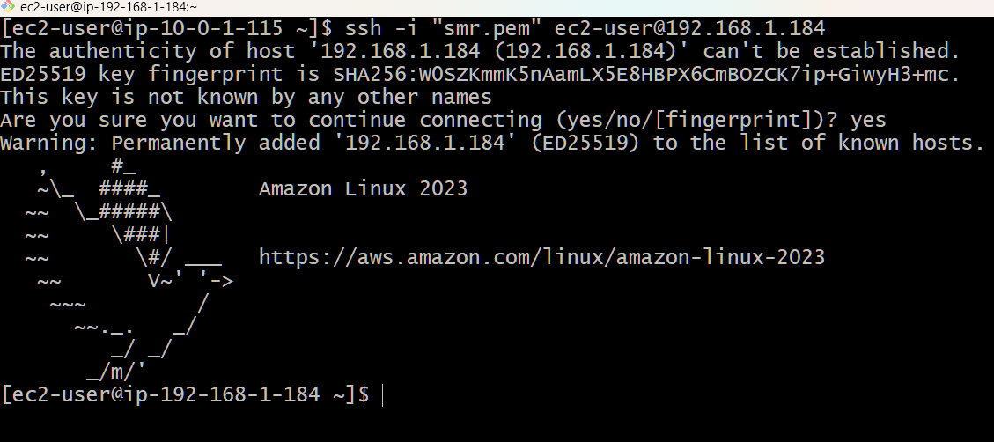
5) Set up a VPC Endpoint.
Created on endpoint with full access, s3 and vpc
• And created one policy and selected the policy i
created
• And changed the json policy allow to deny and
checked it worked
